**Team Name:** Noble Team

**Current Leader:** Tanya Malik

**Members:** Melanie Brown, Marwan Elashry, Viren Kumar, Tanya Malik, Emily Nolan, and Lucas Scharf

Zoom link for meeting: <https://gmu.zoom.us/j/99457453437?pwd=WTRIcjFIQXhJTklwRWNBaVl0L3NhUT09>

**Melanie Brown:**

I was able to add more to the flow chart. I created a high-level overview of the attack as well as steps for the malicious website setup and steps for changing Cortana’s response text/link.

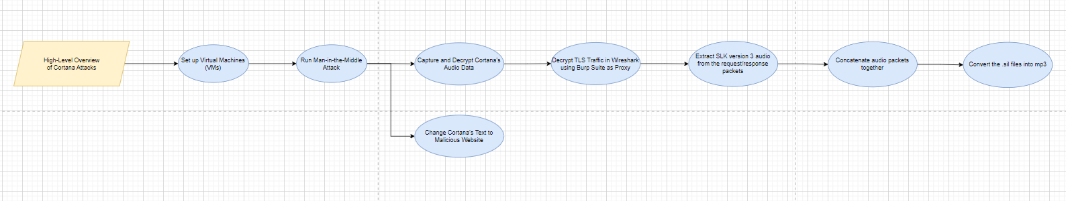



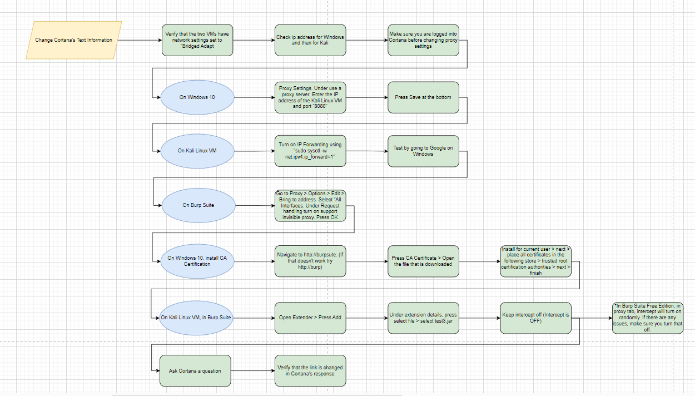

**Marwan Elashry:**

Typed the implementation section in the abstract paper and created the outline for the SAGE report.

**Viren Kumar:**

1. Added in Verification & Validation section to the Abstract
2. Added IP and Date to logging on the phishing website

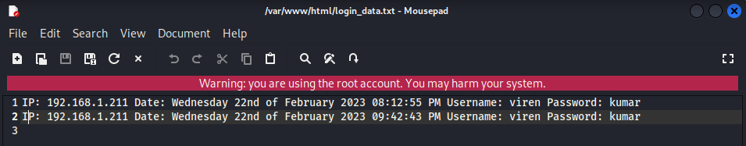

1. Got phishing website to work on Emily’s machine
2. In progress of compiling updated java code into a test4.jar file, replaced the url to the ip address of the phishing website

**Tanya Malik:**

Summary Here 2-3 sentences

**Emily Nolan:**

Viren and I got the new website to work on my machine because last week it wasn't saving the login info. Now the website I have saves the login info and the IP and the timestamp. We also were able to successfully replace Cortana's response to be a different link. All that is left is to recompile the java code to reflect our link, not Blue Halos. I also did the sage outline and helped with writing the abstract for the competition that is due tomorrow.

**Lucas Scharf:**

Summary Here 2-3 sentences